地源热泵

简介
地源热泵， Name des Artikels， Name of the article，是指利用浅层地热能为建筑供冷、采暖或制生活热水的热泵装置。1)

工作原理
冬季： 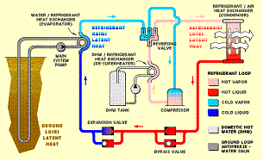 地源热泵将地热能传递入建筑以为建筑采暖。 Geothermal heat pumps transfer underground heat into buildings to provide heating.
夏季： 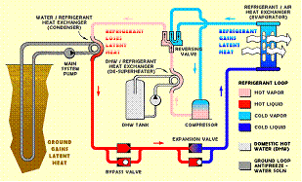 地源热泵将热能从建筑传递入地下以为建筑制冷。 Geothermal heat pumps transfer heat from buildings into the ground to provide cooling.

分类
1、垂直埋管地源热泵Vertical Closed-Loop
一对底部装配有特殊U型的管道放置在100至400英尺深的孔洞中。 A pair of pipes with a special U-bend assembly at the bottom is placed into bore holes from 100 to 400 feet deep 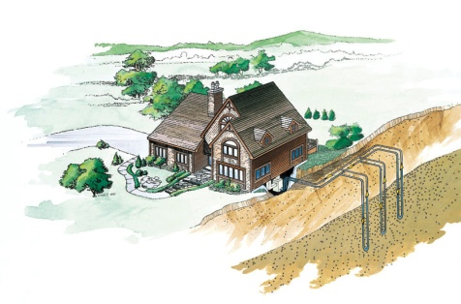
2、水平埋管地源热泵Horizontal Closed-Loop
管道阵列安装在沟槽中，切割深度为3到5英尺，长度达数百英尺。 A piping array is installed in trenches cut 3 to 5 feet deep and hundreds of feet in length 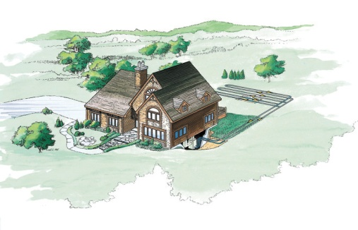
3、地表水源热泵Surface Water Closed-Loop
管道阵列被淹没在池塘或湖泊中，至少8英尺深 A piping array is submerged in a pond or lake at least 8 feet deep 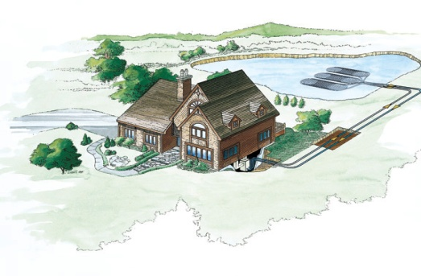
4、地下水源热泵Ground Water Open-Loop
井水从地下含水层通过地热泵抽水，然后返回含水层或排放到地表。在此处键入公式。 Well water from an underground aquifer is pumped through the geothermal heat pump and then returned to the aquifer or discharged to the surface 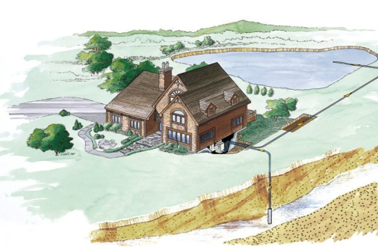

参考文献

1) 作者姓名，参考文献名称，发表年限，发表地点 - 进一步说明

